Beacon Labs - Lab Report

Name: INSTRUCTOR | Date: (Date of lab completion)
Lab Name: EVIL TWIN DETECTION

(Description of the task and how you completed it. Include words and images as necessary)

Objective of this lab

The objective of this lab is to provide a comprehensive understanding of the Evil Twin attack in WiFi networks and its mitigation techniques, specifically focusing on the implementation of the EvilScout method. The lab offers hands-on experience in setting up and executing an Evil Twin attack, which involves creating a rogue access point that mimics a legitimate one to deceive clients into connecting to it. I will learn how to replicate a router's hardware address and name, use the Mininet-WiFi software to simulate a WiFi network topology, and implement prevention measures on the legitimate access point (LAP) side. Additionally, the lab introduces the application of game theory in cybersecurity, providing an analytical framework to understand the strategic interaction between an attacker and a defender in the context of the Evil Twin attack.

Task Set 1
Task 1.1: Simulating the Network Topology
Action
    - cd (change directory) into /home/mininet/Documents/mininet-wifi/examples and Run miniedit.py with python miniedit.py.

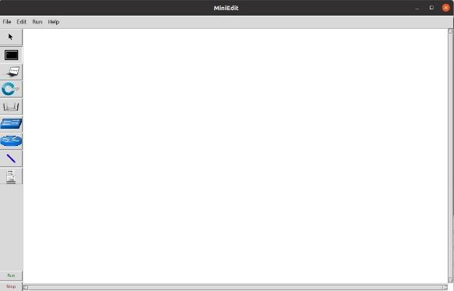
Figure 1. Mininedit’s interface

    - Create the topology as specified in the instruction document:

Make sure that there are links between the controller, switch, and access point; the switch and access point; and the switch and host.

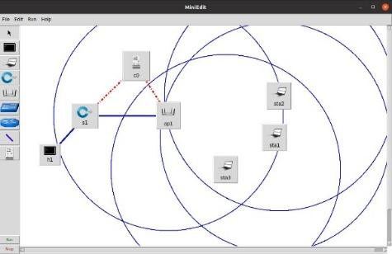
Figure 2. The topology
    - Alter the properties of the access point to have two WLANs and use channel six. Click OK then Save as a topology.mn file and Export as a Level 2 Script named topology.py

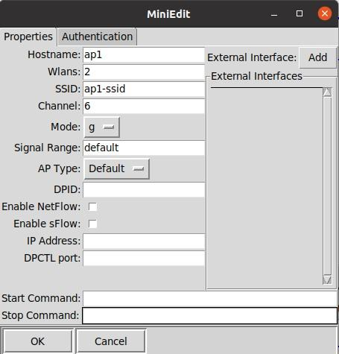
Figure 3. The edited properties
Add wlans=2 to the topology python script if it is not included when exported from miniedit.py.

Open the script with gedit topology.py and navigate to the line shown below to add wlans=2 if it’s not already there. During testing, it was never added in automatically but mininet-wifi claims that it will be so we mention this as something to check and may be necessary but may not be.

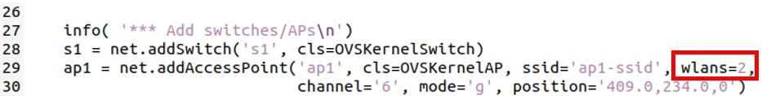

Task Set 2
Task 2.1: Setting Up the Evil Twin Attack
Action
2.1.1. The mininet interactive terminal should’ve been started by running the command `sudo python topology.py`. Open an xterm terminal for Station 1 by entering xterm sta1 into the mininet terminal. Alter the hw ether on station 1’s interface to match the LAP’s hardware address, and then stop and restart the node.

In the Station 1 xterm terminal enter the following commands

```console
$ ifconfig sta1-wlan0 down
$ ifconfig sta1-wlan0 hw ether 02:00:00:00:03:00
$ ifconfig sta1-wlan0 up
```

The above commands do the following:
- Turn off the sta1-wlan0 interface
- Change the ether class hardware address (hw) to 02:00:00:00:03:00 which is the same as the LAP’s hardware address (the command can be read as “configure interface sta1-wlan0’s ether hardware address to 02:00:00:00:03:00” and the generic syntax would look like this: ifconfig <interface> <value_to_change> <class> <new_value>)
- Turn on the sta1-wlan0 interface

Then back in the mininet terminal enter the following commands:

```console
mininet> py sta1.stop_()
mininet> py sta1.start_()
```

The above commands turn the node off and then back on again.

Verify the changes by running ifconfig in the Station 1 xterm terminal and verifying the MAC address under the ether category for ap1-wlan0 is set to 02:00:00:00:03:00.

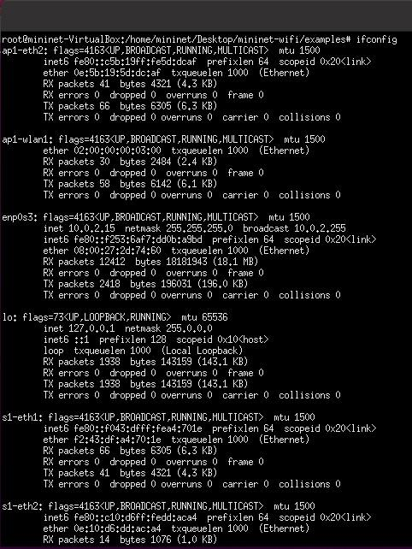

LAP’s hardware address

2.1.2. Set the sta1-wlan0 interface to master mode with the LAP’s ESSID by entering the following command into the mininet terminal.

mininet> py sta1.setMasterMode(intf='sta1-wlan0', ssid='ap1-ssid', channel='6', mode='g')

The above command tells mininet-wifi to change Station 1’s sta1-wlan0 interface’s mode to master, update its ssid to ap1-ssid, and move it to channel 6.
2.1.3. Run the command iw sta1-wlan0 info to verify if the hardware address, network name, and channel are correct, and the interface is running in master mode

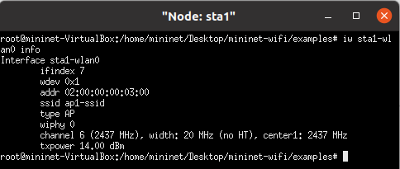

2.1.5. Use one of the other stations to scan for networks and see what happens if the evil twin is running on the same channel vs a different channel and include the difference in your lab report.

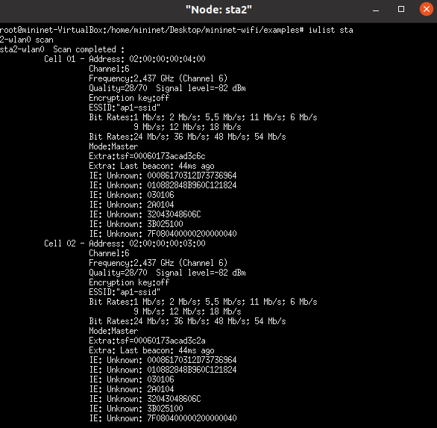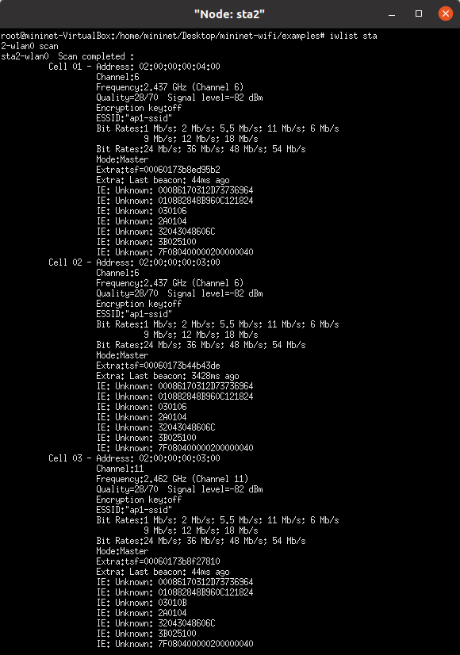

Open an xterm terminal for station 2 by entering xterm sta2 into the mininet terminal. Once in the station 2 terminal, run iwlist sta2-wlan0 scan to find the available interfaces it can interact with. When Station 1’s sta1-wlan0 interface is on the same channel (channel 6) as Station 2’s sta2-wlan0 interface, there will be a third interface shown in the scan results (Cell 03) whereas when sta1-wlan0 is on a different channel, only two will be shown when sta2-wlan0 scans.

Before changing the channel for Station 1, restart the node.

Stop Station 1 with py sta1.stop_()
Start Station 1 again with py sta1.start_()
py sta1.setMasterMode(intf='sta1-wlan0', ssid='ap1-ssid', channel='11', mode='g')

2.1.6. Set the evil twin (station 1) to be on the same channel as the LAP and connect station 2 to it.

Set the evil twin to be on the same chanel(6)
Stop Station 1 with py sta1.stop_()
Start Station 1 again with py sta1.start_().
Set the channel py sta1.setMasterMode(intf='sta1-wlan0', ssid='ap1-ssid', channel='6', mode='g')

Connect station 2 to the evil twin (run from the sta2 xterm terminal, opened with xterm sta2 in the mininet terminal):
iwconfig sta2-wlan0 essid ap1-ssid

The above command associates (connects) the station 2 sta2-wlan0 interface to the access point bearing the ap1-ssid ESSID. Depending on which one iwconfig finds first, this will connect Station 2 to either the LAP or the Evil Twin (Station 1).
2.1.7. Verify if the client is connected to the evil twin or the LAP by running tcpdump on the access point and pinging a random IP address from the client.

With tcpdump running on the access point, no tcp traffic will be dumped if the station is connected to the evil twin as intended but, if the station is connected to the LAP, then traffic will show up here. It’s a good idea to also run tcpdump on the evil twin to verify that Station 2 is actually connected to it but this isn’t necessary.

tcpdump on ap1 (opened with xterm ap1 in the mininet console)
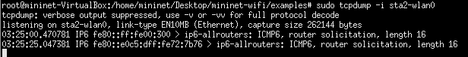

ping 10.0.0.1 is run from the Station 2 xterm terminal.
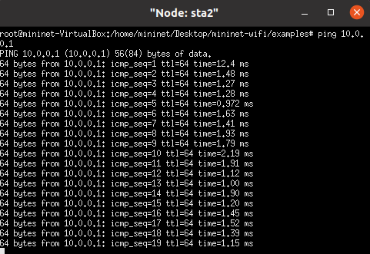

Task Set 3
Action
3.1.1. Set the second WLAN on the access point to monitor mode instead of master mode. In the ap1 xterm terminal, execute the following commands:

```console
$ ifconfig ap1-wlan2 down
$ iwconfig ap1-wlan2 mode monitor
$ ifconfig ap1-wlan2 up
```

The above commands do the following:
- Turn the ap1-wlan2 interface off
- Change the mode for ap1-wlan2 to monitor
- Turn the ap1-wlan2 interface back on
3.1.2. Run the command above on the LAP (ap1). Your terminal should look like Figure 6.
airodump-ng ap2-wlan1

This command will provide information about access points, connected stations, and some information about the traffic occurring on it.
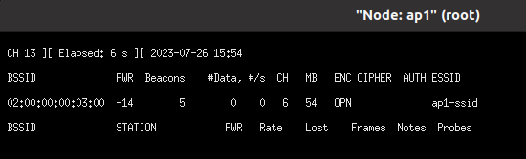
3.1.3. Try sending packets from the client to the evil twin.
ping 10.0.0.1 should be executed from Station 2
3.1.4. Note in your lab report which field increases.
When you send a ping command, you're actually sending ICMP (Internet Control Message Protocol) echo request packets to the destination IP address. In the output, the icmp_seq field corresponds to the sequence number of the ICMP packet. The icmp_seq field is used to match the request with the response. Each time you send a ping, the icmp_seq number increases.

So, in the output, the field that is increasing is the icmp_seq field. It starts at 1 for the first ping packet, then increases by 1 for each subsequent packet.

a capture file can be created using the command below for use with evil scout.
On the ap1 xterm terminal, execute the following command:
airodump-ng --bssid 02:00:00:00:03:00 --channel 6 --write ap1-capture ap1-wlan2

This command captures traffic coming to the access point with the specified BSSID over channel 6 and then writing to the defined capture file (in this case, “ap1-capture-01.cap” will be the created file). All this is done using the ap1-wlan2 interface which needs to be in monitor mode in order to monitor traffic.

Once that command is running, go back to Station 2’s xterm terminal and execute another ping 10.0.0.1 command. On the ap1 terminal, you should see the “#Data” column go from 0 to 1. Once it does, wait a few seconds to ensure that enough packets are sent over and tracked before stopping airodump-ng. You may need to stop and restart the airodump-ng command a few times before it works. If you restart the airodump-ng command more than 3 times, try doing the following in the mininet terminal:

```console
mininet> sta2 iw dev sta2-wlan0 disconnect
mininet> sta2 iw dev sta2-wlan0 connect ap1-ssid
```

The above two commands simply disconnect and connect station 2’s sta2-wlan0 interface from/to the access point with the ESSID of ap1-ssid

Then execute sta2 iw dev sta2-wlan0 link in the mininet terminal until it shows connection details and not “Not connected.”

Action
3.2.1. Complete the EvilScout.py and run it on the LAP, using the code skeleton for the script (Figure 7) provided in the documents folder.

Here is the completed code that we made. Do note that this is not the only solution, just one way of attaining the desired outcome.

```python
#/usr/bin/env python3
from scapy.all import *
import subprocess

filename = 'ap1-capture-01.cap'

def stationList():
cmd = ['iw', 'dev', 'ap1-wlan1', 'station', 'dump']
output = subprocess.Popen(cmd, stdout=subprocess.PIPE).communicate()[0]
output_string = output.decode()

station_list = []
for line in output_string.split(sep='\n'):
if line.startswith("Station"):
chunked_line = line.split(sep=' ')
station_list.append(chunked_line[1])

return station_list

def evilScout(pkt):
# Setting variables
try:
sourceIp = pkt[ARP].psrc # Get the packet source ip from the ARP layer
sourceMac = pkt[ARP].hwsrc # Get the packet source hardware address from the ARP layer

sourceIpPrefix = sourceIp.rsplit('.', 1)[0] # Use a bubstring to get the ip prefix of the captured
assignedIpPrefix = "10.0.0" # What ip prefix is being assigned by the LAP

# Case 1
print("CASE 1")
print("Captured ip-prefix: " + sourceIpPrefix)
print("Expected ip-prefix: " + assignedIpPrefix)
if sourceIpPrefix != assignedIpPrefix: # If the captured prefix isn’t the same
print("CASE 1 TRUE") # then case 1 is true
return True

# Case 2
currentStationList = stationList() # Finish the method to produce the MAC
# addresses
print("CASE 2")
print("captued MAC: " + sourceMac)
print("stations alloted: ")
print(*currentStationList, sep = ", ")
if not (sourceMac in currentStationList):
print("CASE 2 TRUE")
return True
except:
return False

if __name__ == "__main__":
packets = rdpcap(filename)
found = False

print("Num packets: " + str(len(packets)))
for packet in packets:
if evilScout(packet):
print("Evil Twin Detected!")
found = True
break

if found == False :
print("No Evil Twin Detected!")
```

The below screenshot is what the terminal will look like after creating the capture file and running EvilScout.py on the legitimate access point, ap1.
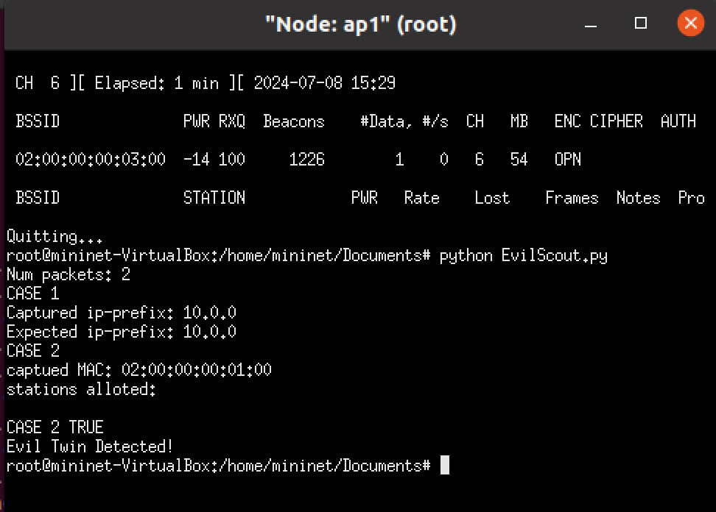

Action
3.3.1. Run iwconfig on the client and see that it is connected to the evil twin (denoted by the access point being not-associated but the ESSID being ap1-ssid).
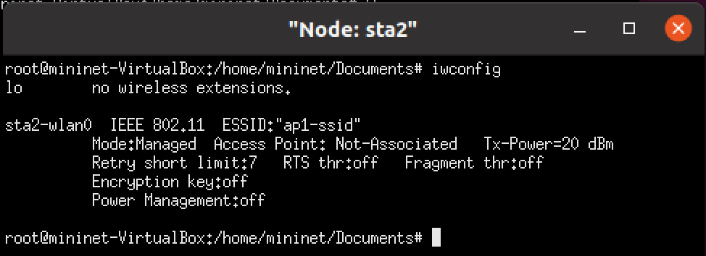
3.3.2. Run the aireplay-ng command in the ap1 xterm terminal and compare the difference.

aireplay-ng -0 0 -a 02:00:00:00:03:00 -c 02:00:00:00:01:00 ap1-wlan2

This command causes the device with a hardware address of 02:00:00:00:01:00 to be sent DeAuth codes using the device on the LAP with the hardware address 02:00:00:00:03:00 and all the traffic reporting is done using the ap1-wlan2 interface.

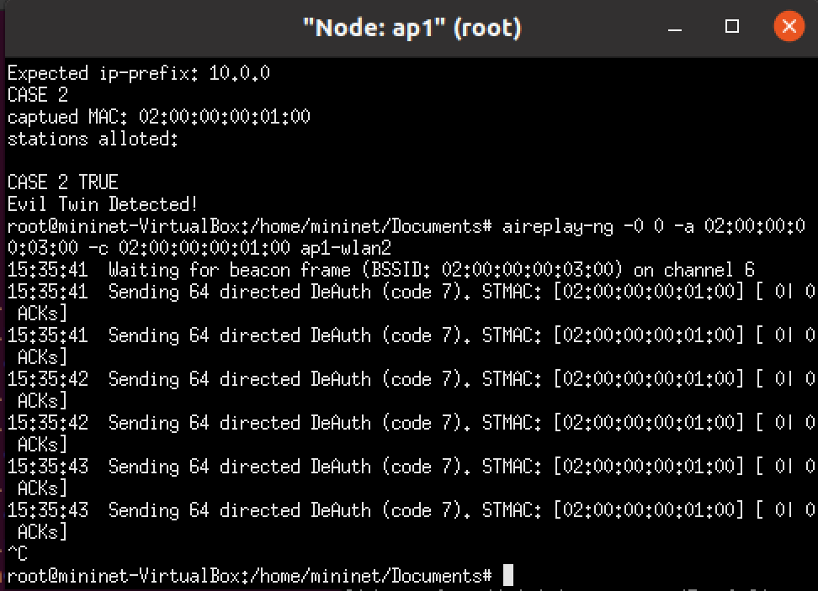
iwconfig

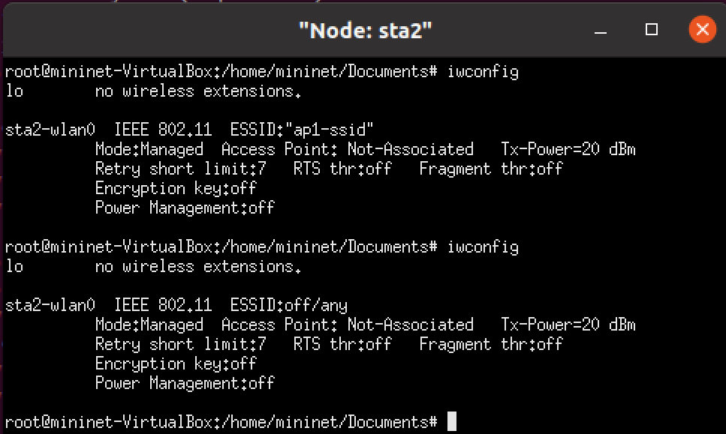
The second instance of sta2-wlan0 in the screenshot is what should be showing up (some minor differences may appear). As long as the ESSID is set to off/any and access point to not-associated, the aireplay-ng command succeeded.

Task Set 4

Based on the game theory table and the information provided in the document, here are the answers to the questions in Task 4:

 |  | Player2. Server
Play1. Attacker |  | Evil Scout | Nothing
 | Long Attack | (0, 2) | (2, 1)
 | Short Attack | (1, 1) | (1, 2)
 | Nothing |  | (1, 1)

1. Should player one always choose to attack? Why?
- Player one (the attacker) should not always choose to attack. The decision to attack should be based on the potential benefits and risks. If the attacker believes that the server will not implement the Evil Scout, then a long attack would be 2. However, if the attacker believes that the server will implement the Evil Scout, then not attacking and a short attack would be the best choice (benefit of 1).

2. When attacking, should a short or long attack be used?
- If the attacker decides to attack, the choice between a short or long attack depends on the expected response of the server. If the attacker believes that the server will not implement the Evil Scout, then a long attack would yield a higher benefit (benefit of 2 compared to 1 for a short attack). However, if the server is expected to implement the Evil Scout, a short attack would result in a benefit of 1. If the attacker doesn’t know if the server implements it or not, the short attack would be the best choice.

3. Knowing that the server is unaware of the attack being short or long, should player 2 implement evil scout or do nothing?
- The server should base their decision on the expected actions of the attacker. If the server believes that the attacker will not attack, then doing nothing would yield a benefit of 1. However, if an attack is expected, implementing the Evil Scout would be beneficial. In the case of a long attack, the Evil Scout would yield a benefit of 2 (compared to 1 for doing nothing), and in the case of a short attack, doing nothing would yield a benefit of 2. Thus, there's no difference in expected actions between implementing "Evil Scout" or "Nothing", so the server could choose either action without any expected benefits or risks.

